KAIST Development Foundation Agreement
Personal Informaion |  |  | ※ Your personal information will be used only for tax report.
Name  (Business Name) |  |  |  |  | Resident Registration No.  (Business Registration No.)
Classification | ▢ KAIST Alumni Major: Admission Year: |  |  |  |  |  |  |  |  | ▢ 기 업 | ▢ 단 체
 | ▢ KAIST Parent Student’s name: Major: Admission Year:
 | ▢ KAIST Faculty and Staff Dept.: ▢ Other
Address
Contarct | Mobile ( ) - ▢ Home ▢ Work ( ) - |  |  |  |  | E-mail

Contract |  | ※ We will gladly visit you, provided that you want to donate assets in kind, like bequest and real estate
Amount | Total (￦ )
Use | ○ General development fund (KAIST is entrusted for its use.)
○ Designated development fund

○ Academy | ○ Scholarship | ○ Research | ○ Facilities | ○ Library | ○Named endowed chair professer
○ Department ( ) |  |  | ○ Others ( )

Remarks | Do you want to keep the capital intact? ▢ Yes (using the interest only) ▢ No (using the capital)

Method of Donation |  | ※ Account No.: Woori Bank 270-003359-01-005, Account holder's name: KAIST
Single Payment | ▢ Date of Deposit(MM/DD/YYYY)
 | ▢ Check Enclosed(MM/DD/YYYY)
Installment Payment | Period: From(MM/YYYY) to(MM/YYYY) ( Months), Amount: ￦ /Month
▢ CMS, Cash Management Service(Donor can let KAIST withdraw the amount of donation/month.)
Bank: Account No.: Account holder's name:
Bank: Account No.: Account holder's name:
 | ▢ Automatic Transfer(Donor should make a payment.)
 | ▢ Salary Deduction(for school staff only)

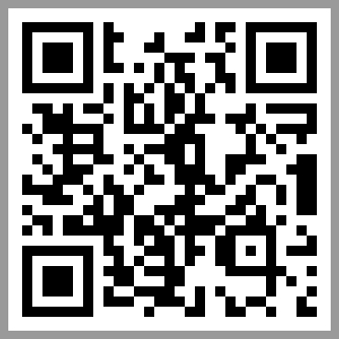 | KAIST Development Foundation  Tel. (042) 350 - 4500 Fax. (042) 350 - 3500  E-mail. foundation@kaist.ac.kr  http://giving.kaist.ac.kr | I hereby pledge to make an agreement of  KAIST development fund as stated above.  I grant consent to DB to collect and use my  personal information as above.  Date(MM/DD/YYYY):
※ This agreement means to be one of supporters for
KAIST development
 |  | Signature:

